Excel Assignment 2
- What is data cleaning, and why is it important in data analysis?
- It is the process of identifying, correcting or removing errors, inaccuracies and irrelevant data from datasets to improve overall data quality for analysis and decision-making.
- What are the potential consequences of analysing unclean or messy data?
- It will lead to inaccurate results and poor decisions, incorrect reporting, gaps, performance degradation, significant time spent on manual cleaning instead of analysis.
- Explain the common steps involved in cleaning and organizing data.
- It involves identifying the issues and fixing error, inconsistencies and missing values then finally structuring it through steps like accessing qualities, removing duplicates, fixing errors, handling missing data, standardizing formats, managing outliners, and validating against rules.

- How would you sort the following dataset first by "Department" (A-Z) and then by "Salary" (Largest to Smallest)? Write a step-by-step approach.

Employee | Department | Salary
Sonu | IT | 4000
Pranav | HR | 5000
Rahul | IT | 2500

- Select the “Department” column, go to the data tab and choose A-Z sort option and it will give the expand the selection option in dialogue box choose this and it will give result in alphabetical order.

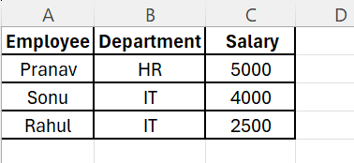

- Select the “Salary” column, in the home tab, choose sort and filter option and click largest to smallest option and expand the selection and it will give correct result.



- Explain the use of text functions such as TRIM, LEFT, RIGHT, MID, and CONCAT in data cleaning.
- TRIM- Cleans the data by removing unnecessary spaces between words and leaving single space.
- LEFT- It extracts a specific number of character from the beginning (left) of a text string.
- RIGHT- It extracts a specific number of character from the end (right) of a text string.
- MID- It extracts character from middle of a text string, using syntax =MID(text, start_num, num_chars).
- CONCAT- It combines the text from multiple cells into one cell, adding spaces within double quotes as needed.

- What is the role of date functions like TODAY in managing datasets?
- This function in excel inserts the current data, automatically updating whenever the workbook opens, making it crucial in tracking deadlines. Using TODAY() into cell and and format the cell inti date for proper display.

- Apply Data Validation to restrict Quantity values to only whole numbers between 1 and 10.

Customer Name | Category | Product Name | Quantity | Unit Price($)
Jane Smith | Shoes | Electronics |  | 81
Alex Moore | Shoes | Electronics |  | 500
Isabella Davis | Headphones | Electronics |  | 348
Isabella Moore | Laptop | Electronics |  | 121
Michael Johnson | Table Lamp | Home Decor |  | 423
Jane Davis | Headphones | Electronics |  | 152
Daniel Davis | Sofa | Clothing |  | 239
Daniel Johnson | Backpack | Electronics |  | 160
Alex Wilson | T-shirt | Home Decor |  | 369

- Configure an input message that appears when a user selects a cell in the "Quantity" column explaining:

"Please enter a whole number between 1 and 10."
- Select the cells under Quantity column (D2 to D10), go the data tab and click data validation under data tools group, the dialogue box will open and in setting tab:
Allow- Whole number, Data- Between, Minimum-1, maximum- 10
It will restrict the entries between 1 and 10 and in input message tab check show input message when cell is selected enter:
Title – Quantity input, Input message- “Please enter a whole number between 1 and 10.” This message will appear when a user selects a Quantity cell. Click Ok to apply.

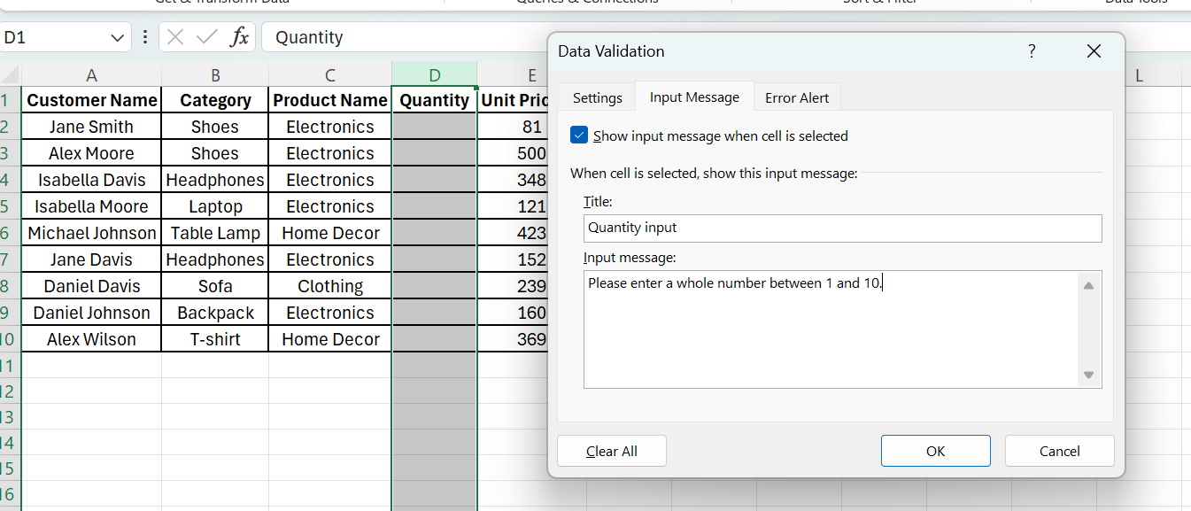

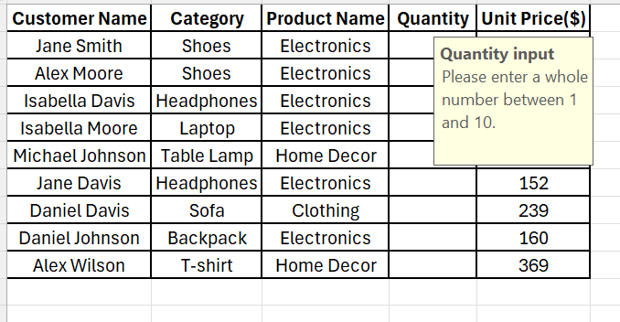

- Set up an error alert message that triggers if the user enters a number less than 1 or greater than 10, showing:

"Invalid input! The quantity must be a whole number between 1 and 10."
- After doing the above steps for input message the select the error alert tab, check show error alert after invalid data is entered:
Style- Stop, Title- Invalid Input, Error message- “Invalid input! The quantity must be a whole number between 1 and 10.” Click Ok to apply.

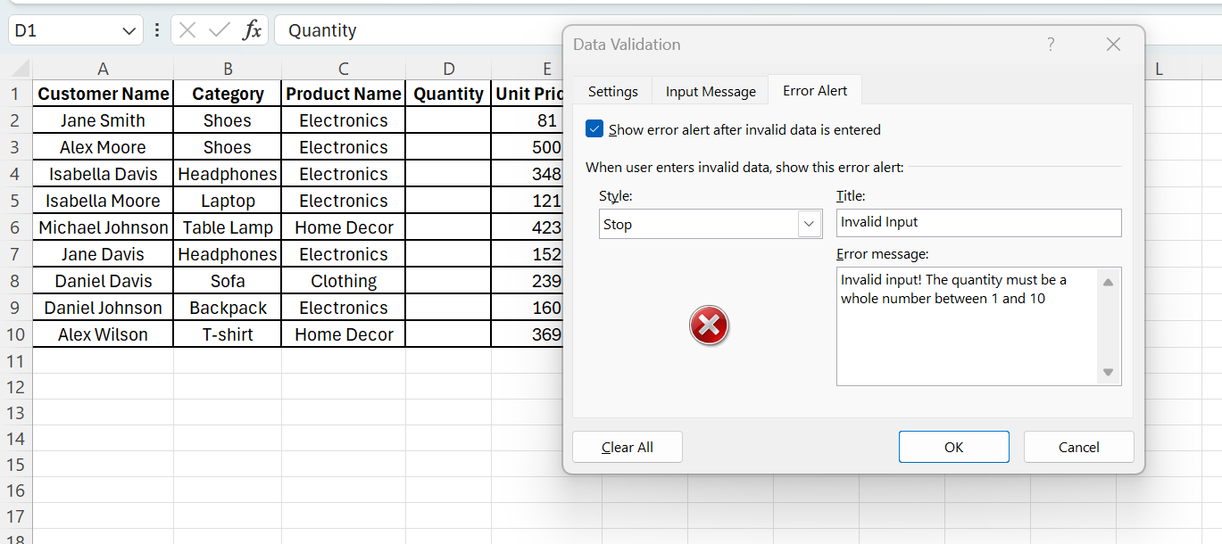

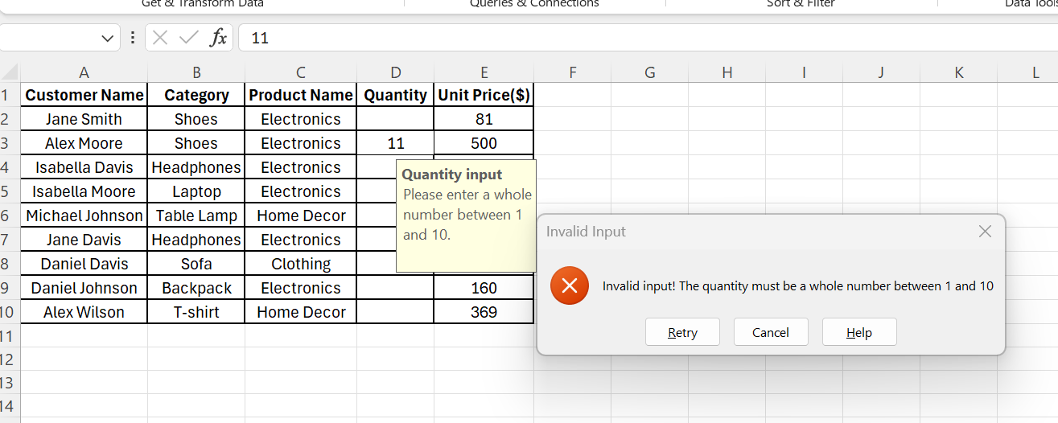

- Understand and apply fundamental text functions like LEFT, RIGHT, MID, and LEN.
  - Extract the first 5 characters from the string "ExcelTipsAreGreat" using the LEFT function.
- =LEFT(“ExcelTipsAreGreat”, 5)
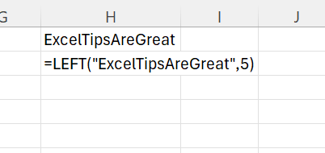

  - Extract the last 4 characters from "DataAnalysis.xlsx" using the RIGHT function.
- =RIGHT(“DataAnalysis.xlsx”, 4)
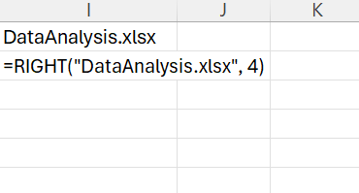

  - Extract the substring "Tips" from "ExcelTipsAreGreat" using the MID function.
- =MID(“ExcelTipsAreGreat”, 6, 4)
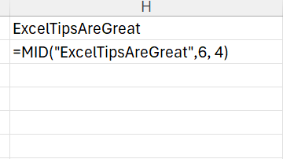

  - Count the total number of characters in the string "Hello World!" using the LEN function.
- =LEN(“Hello World!”)
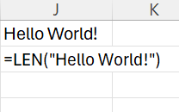
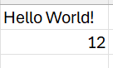

  - Create a formula to extract the middle 6 characters from "12345-67890-ABCDE".
- =MID(“12345-67890-ABCDE”, 7, 6)
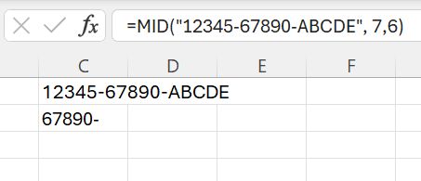

- Understand how to combine text using CONCAT, TEXTJOIN, and the & operator.
- Use CONCAT to combine "Hello" and "World" with a space in between.
- =CONCAT(“Hello”, “ “, “World”)
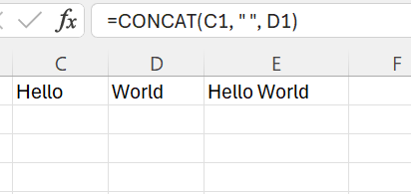

- Combine "Apple", "Banana", and "Cherry" into a single string separated by commas using TEXTJOIN.
- =TEXTJOIN(“, “, TRUE, “Apple”, “Banana”, “Cherry”)
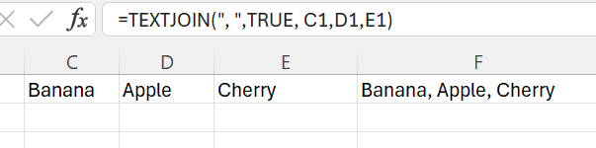

- Use the & operator to create the string "2025: Excel Functions" by combining "2025", ": ", and "Excel Functions".
- =”2025”&”: “&”Excel Functions”
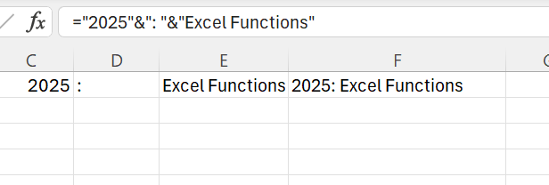

- Create a comma-separated list from the range A1:A5 using TEXTJOIN.
- =TEXTJOIN(“, “, TRUE, A1:A5)

- Combine first names in column A with last names in column B to create full names in column C.
- =A2&” “&B2

- Understanding TODAY() and NOW()
  - What is the difference between TODAY() and NOW() in Excel? Provide an example of when you would use each function.
- TODAY() returns only the current date
- NOW() returns the current data and current time
If it returns with date make sure to change the cell format in dd-mm-yyyy hh:mm
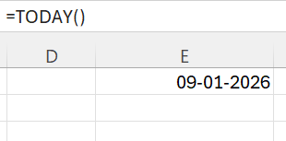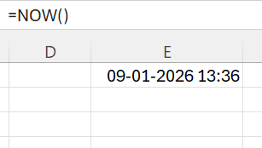

  - If cell A1 contains the date 2025-06-10, write a formula using TODAY() to determine how many days are left until that date
- =A1 – TODAY()
- Dates and time that are in negative or too large shows as ######

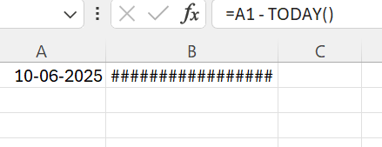

  - Write an Excel formula using NOW() to display the current date and time in the format MM/DD/YYYY HH:MM AM/PM.
- =NOW()
- Then apply custom format in cell
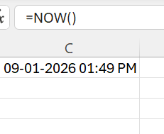

  - If a cell contains =TODAY(), what will happen when the worksheet is reopened the next day? Explain
- The date automatically updates.
- When the worksheet is opened the next day, the cell will show the new current date.

  - You want to store a static date (today’s date) in a cell without it changing every day. What keyboard shortcut should you use?
- Ctrl + ;

